**Perform Taper turning by using compound rest.**

**Apparatus:**

Lathe machine, MS rod.

**Figure:**

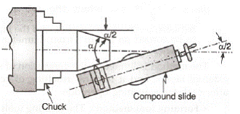

**Theory**

Tapper turning is an operation in which diameter of work piece is gradually increasing or decreeing

**Taper turning methods in lathe machine**

There are four methods

1. Form tool method

2. Tailstock set over method

3. Compound rest method

4. Taper turning attachment method

**Form tool method**

This is one of the simplest methods to produce short taper. This method is shown in the above figure. To the required angle the form is grounded. The tool is fed perpendicular to the lathe axis, when the work piece rotates.

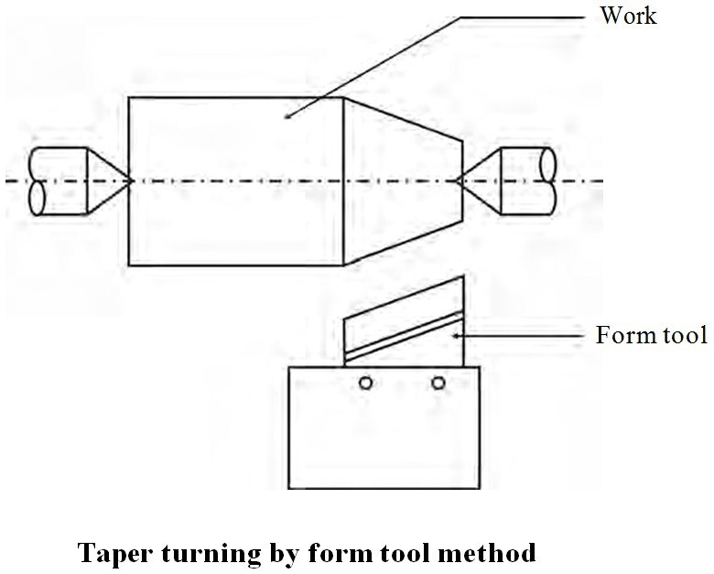

The tool cutting edge length must be greater than the taper length. Since the entire cutting edge removes the metal, it will produce a lot of vibration and hence a large force is required. It is done in slow speed.

**Tailstock set over method**

Generally, when the angle of taper is very small this method will be employed. The work piece be placed in the live center and live center. Now, the tailstock will be moved in a cross wise, that is perpendicular to the lathe axis by turning the set over method. This process is known as tail stock set over method.

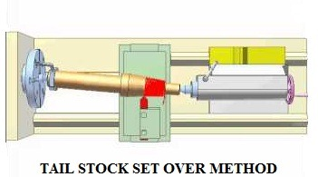

Hence here the job is inclined to the required angle. When the work piece rotates the tool is moved parallel to the lathe axis. So that the taper will be generated on the work piece.

**Compound rest method**

Generally short and steep taper will be produced will be produced using this method. In this method the work piece will be held in the chuck and it will be rotated about the lathe axis. The compound rest is swiveled to the required angle and then it will be clamped in position.

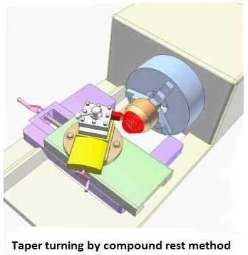

The angle is determined using the formula, tan

Then by using the compound rest hand wheel the tool will be fed. Both the internal and external taper can be done using this method. The important feature is that the compound rest can be swiveled up to 45° on both sides. Only with the help of the hand the tool should be moved.

**Taper turning attachment method**

In this method by using bottom plate or bracket, a taper turning attachment is attached to the rear end of the bed. It has a guide bar which is usually pivoted as its center. The guide bar has the ability to swing and it can be set in any required angle. It has graduations in degrees. On either side, the guide bar can be swiveled to a maximum angle of 10°. It has a guide block which connects to the rear end of the cross slide and it moves on the guide bar. The binder screw is removed, before connecting the cross slide, hence the cross slide is free from the cross slide screw.

The angle is calculated using the formula,

**tanα = (D-d)/2l**

When the division is given in mm instead of degree, then the angular distance of the guide bar to be tilted is given by Using the compound rest hand wheel the depth of cut will be given. At an half taper angle the guide will be set. Using this method any taper turning method can be done.

**Procedure**

* Measure initial diameter and mark the length where want to perform taper turning
* Calculate angle by using Tanθ,and adjust angle on compound rest
* Give depth of cut to cross slide and feed to compound rest

**Observations and Calculations**

|  |  |  |  |  |
| --- | --- | --- | --- | --- |
| Sr.No | Length of rod | Initial Diameter | Final Diameter | Taper Angle |
|  | L | Di | Df | α=Tan(Di-Df\2L) |
| 1 |  |  |  |  |
| 2 |  |  |  |  |

**Questions**

Write different methods to performing taper turning?

_________________________________________________________________________________________________________________________________________________________________________________________________________________________________

Is it possible to perform taper turning by using carriage?

________________________________________________________________________________________________________________________________________________________________________________________________

What is difference between orthogonal and oblique cutting?

________________________________________________________________________________________________________________________________________________________________________________________________